Micro Project Report
On 09/04/2025
Process Scheduler

Branch | Diploma in Computer Engineering
Semester | 4th
Subject Name | Advanced Object Oriented Programming
Subject Code | 4340701

Group Members
Sr. No. | Enrollment Number | Name
1 | 236020307196 | Shyara Sohamkumar N.
2 | 236020307199 | Solanki Ayush J.
3 | 236020307206 | Tanna Krishna K.
4 | 236020307229 | Visavadiya Niraj C.

Index
Sr. No. | Topic Name
1 | Abstract
2 | Introduction to JAVA concepts used in project
3 | Introduction to Project Functionalities
4 | Coding
5 | Output Screenshots

Abstract:-

- This project presents a Java-based Process Scheduler designed to simulate CPU scheduling algorithms used in operating systems. The scheduler implements various scheduling techniques, including First-Come, First-Served (FCFS), Shortest Job First (SJF) and Round Robin.
- The program allows users to input process details such as arrival time, completion time and then computes key metrics like turnaround time, waiting time for each process.
- The goal of the project is to provide a visual and interactive platform to understand how different scheduling algorithms impact process execution and CPU efficiency.
- This scheduler aids students and developers in learning operating system concepts through hands-on simulation and comparison of algorithm performance.

Introduction to JAVA concepts used in project:-

- Class and Object
- States
- Methods
- Constructors
- This keyword
- Access Specifiers

- GUI
  - Classes of swing package such as JFrame, JTextField, JInputPanel, JButton.
  - Different functions for setting background color and font style.
  - Also use awt framework for implement better GUI applications.
  - The code uses event-driven programming to handle user interactions, such as button clicks and text input.

- Packages
- Imports java.util.* for implementing some functions like ArrayList, comparator to sort elements of ArrayList..
- Imports java.util.List for implementing some functions for List
- Imports java.util.Coparator for sorting arrayList elements.
- Imports java.awt.event.* for some specific methods used in code.
- Imports java.swing and java.awt for implementing GUI.

- Collection Framework
- The code uses some built in collection fframe work such as ArrayList , List , Queue and Linked List for better implementation.
- The code uses ArrayList and List for better implementation in FCFS and SJf.
- The code uses Queue for Round Robin because of its complex logic.

Introduction to Project Functionalities:-

- This program provides functionalities such as taking input for process id, process name, process arrival time, process completion time and time quantum(where required).
- Then gives 4 button for adding process in arraylist, calculate using FCFS algorithm, calculate using SJF algorithm and calculate using RR algorithm..
- The code allows user to create new processes by entering their attributes such as Id, Process name , arrival time burts time and many more.
- The code simulates the FCFS , SJF and RR scheduling algorithm , allowing users to select which algorithm to use.
- The code executes the selected scheduling algorithm , displaying the results in a table format.
- The code displays the result of the scheduling algorithm , including the finish time , turnaround time , and waiting time for each processs.
- The code allows users to interact with the GUI including clicking buttons , entering text and viewing results.

Source Code:-

import javax.swing.*;
import java.awt.*;
import java.awt.event.*;
import java.util.*;
import java.util.List;

class Process {
public int id;
public String name;
public int arrivalTime;
public int burstTime;
public int remainingTime;
public int finishTime;
public int turnAroundTime;
public int waitingTime;
public int timeQuantum;

Process(int id, String name, int arrivalTime, int burstTime, int timeQuantum)
{
this.id = id;
this.name = name;
this.arrivalTime = arrivalTime;
this.burstTime = burstTime;
this.remainingTime = burstTime;
this.timeQuantum = timeQuantum;
}
}

public class MicroProject
{
private JFrame frame;
private JTextArea outputArea;
private JTextField idField, nameField, atField, btField, tqField;
private JButton addButton, fcfsButton, sjfButton, rrButton;
private ArrayList<Process> processList = new ArrayList<>();

public MicroProject()
{
frame = new JFrame("Process Scheduler Simulator");
frame.setSize(800, 600);
frame.setDefaultCloseOperation(JFrame.EXIT_ON_CLOSE);
frame.setLayout(new BorderLayout(10, 10));

JPanel inputPanel = new JPanel(new GridLayout(6, 2, 10, 7));
inputPanel.setBorder(BorderFactory.createTitledBorder("Add New Process"));
inputPanel.setBackground(new Color(230, 240, 255));

Font labelFont = new Font("SansSerif", Font.BOLD, 14);
Font fieldFont = new Font("SansSerif", Font.PLAIN, 14);

idField = new JTextField(); idField.setFont(fieldFont);
nameField = new JTextField(); nameField.setFont(fieldFont);
atField = new JTextField(); atField.setFont(fieldFont);
btField = new JTextField(); btField.setFont(fieldFont);
tqField = new JTextField(); tqField.setFont(fieldFont);

inputPanel.add(createLabel("ID:", labelFont)); inputPanel.add(idField);
inputPanel.add(createLabel("Name:", labelFont)); inputPanel.add(nameField);
inputPanel.add(createLabel("Arrival Time:", labelFont)); inputPanel.add(atField);
inputPanel.add(createLabel("Burst Time:", labelFont)); inputPanel.add(btField);
inputPanel.add(createLabel("Time Quantum:", labelFont)); inputPanel.add(tqField);

addButton = new JButton("Add Process");
addButton.setBackground(new Color(144,238,144));
fcfsButton = new JButton("Run FCFS");
sjfButton = new JButton("Run SJF");
rrButton = new JButton("Run RR");

JPanel buttonPanel = new JPanel(new FlowLayout());
buttonPanel.add(addButton); buttonPanel.add(fcfsButton);
buttonPanel.add(sjfButton); buttonPanel.add(rrButton);

inputPanel.add(new JLabel("")); // Empty cell
inputPanel.add(buttonPanel);

outputArea = new JTextArea(10, 50);
outputArea.setFont(new Font("Monospaced", Font.PLAIN, 13));
outputArea.setEditable(false);
JScrollPane outputScroll = new JScrollPane(outputArea);
outputScroll.setBorder(BorderFactory.createTitledBorder("Process Log"));

frame.add(inputPanel, BorderLayout.NORTH);
frame.add(outputScroll, BorderLayout.CENTER);

addButton.addActionListener(e -> addProcess());
fcfsButton.addActionListener(e -> runFCFS());
sjfButton.addActionListener(e -> runSJF());
rrButton.addActionListener(e -> runRR());

frame.setVisible(true);
}

private JLabel createLabel(String text, Font font)
{
JLabel label = new JLabel(text);
label.setFont(font);
return label;
}

public void addProcess()
{
try
{
int id = Integer.parseInt(idField.getText());
String name = nameField.getText();
int at = Integer.parseInt(atField.getText());
int bt = Integer.parseInt(btField.getText());
int tq = Integer.parseInt(tqField.getText());

Process p = new Process(id, name, at, bt, tq);
processList.add(p);
outputArea.append("Added Process: " + name + "\n");

idField.setText(""); nameField.setText(""); atField.setText("");
btField.setText(""); tqField.setText("");

} catch (NumberFormatException ex)
{
JOptionPane.showMessageDialog(frame, "Enter valid input!", "Input Error", JOptionPane.ERROR_MESSAGE);
}
}

public void runFCFS()
{
ArrayList<Process> list = new ArrayList<>(processList);
list.sort(Comparator.comparingInt(p -> p.arrivalTime));

int time = 0;
for (Process p : list)
{
time = Math.max(time, p.arrivalTime);
time += p.burstTime;
p.finishTime = time;
p.turnAroundTime = p.finishTime - p.arrivalTime;
p.waitingTime = p.turnAroundTime - p.burstTime;
}
displayProcess("FCFS Result", list);
}

public void runSJF()
{
ArrayList<Process> list = new ArrayList<>(processList);
list.sort(Comparator.comparingInt(p -> p.burstTime));

int time = 0;
for (Process p : list)
{
time = Math.max(time, p.arrivalTime);
time += p.burstTime;
p.finishTime = time;
p.turnAroundTime = p.finishTime - p.arrivalTime;
p.waitingTime = p.turnAroundTime - p.burstTime;
}
displayProcess("SJF Result", list);
}

public void runRR()
{
ArrayList<Process> queue = new ArrayList<>();
for (Process p : processList)
queue.add(new Process(p.id, p.name, p.arrivalTime, p.burstTime, p.timeQuantum));

int tq = processList.get(0).timeQuantum;
int time = 0;
Queue<Process> readyQueue = new LinkedList<>();
queue.sort(Comparator.comparingInt(p -> p.arrivalTime));
readyQueue.add(queue.remove(0));

while (!readyQueue.isEmpty() || !queue.isEmpty())
{
while (!queue.isEmpty() && queue.get(0).arrivalTime <= time)
{
readyQueue.add(queue.remove(0));
}

if (readyQueue.isEmpty())
{
time = queue.get(0).arrivalTime;
readyQueue.add(queue.remove(0));
}

Process current = readyQueue.poll();
int execTime = Math.min(tq, current.remainingTime);
current.remainingTime -= execTime;
time += execTime;

while (!queue.isEmpty() && queue.get(0).arrivalTime <= time)
{
readyQueue.add(queue.remove(0));
}

if (current.remainingTime > 0)
{
readyQueue.add(current);
} else {
current.finishTime = time;
current.turnAroundTime = current.finishTime - current.arrivalTime;
current.waitingTime = current.turnAroundTime - current.burstTime;
processList.stream()
.filter(p -> p.id == current.id)
.findFirst()
.ifPresent(p -> {
p.finishTime = current.finishTime;
p.turnAroundTime = current.turnAroundTime;
p.waitingTime = current.waitingTime;
});
}
}

displayProcess("RR Result", processList);
}

public void displayProcess(String title, List<Process> list)
{
String[] columns = {"ID", "Name", "Arrival Time", "Burst Time", "Finish Time", "Turnaround Time", "Waiting Time"};
String[][] data = new String[list.size()][7];

for (int i = 0; i < list.size(); i++)
{
Process p = list.get(i);
data[i][0] = String.valueOf(p.id);
data[i][1] = p.name;
data[i][2] = String.valueOf(p.arrivalTime);
data[i][3] = String.valueOf(p.burstTime);
data[i][4] = String.valueOf(p.finishTime);
data[i][5] = String.valueOf(p.turnAroundTime);
data[i][6] = String.valueOf(p.waitingTime);
}

JTable table = new JTable(data, columns);
JScrollPane tableScroll = new JScrollPane(table);
tableScroll.setBorder(BorderFactory.createTitledBorder(title));

frame.getContentPane().add(tableScroll, BorderLayout.SOUTH);
frame.revalidate();
frame.repaint();
}

public static void main(String[] args)
{
new MicroProject();
}
}

Output:-

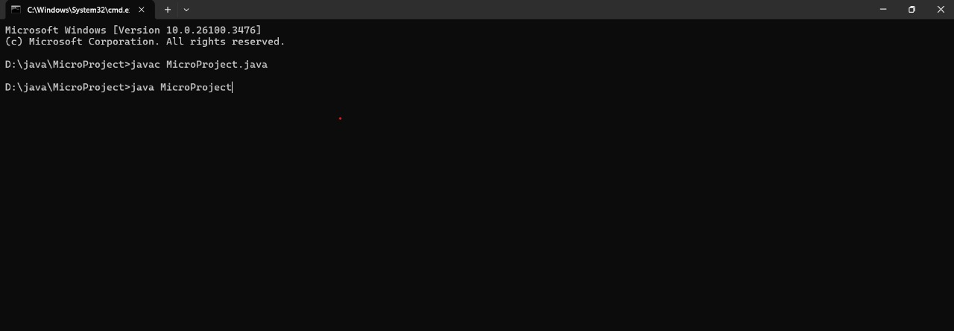

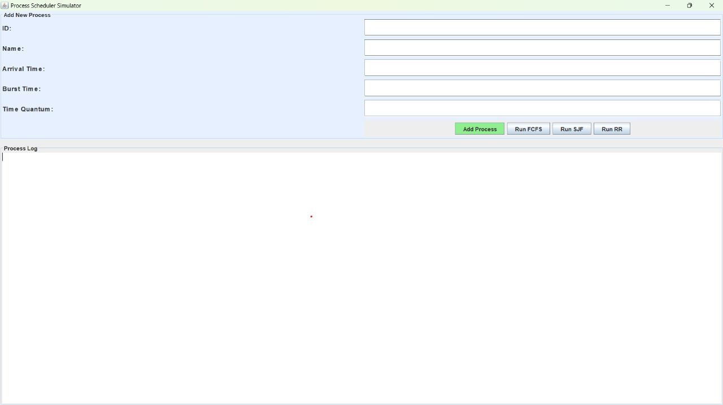
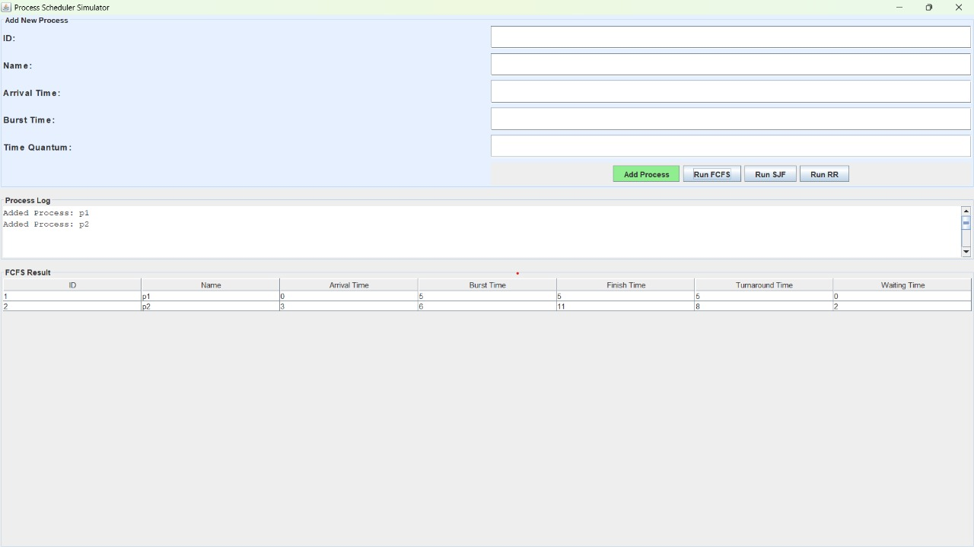

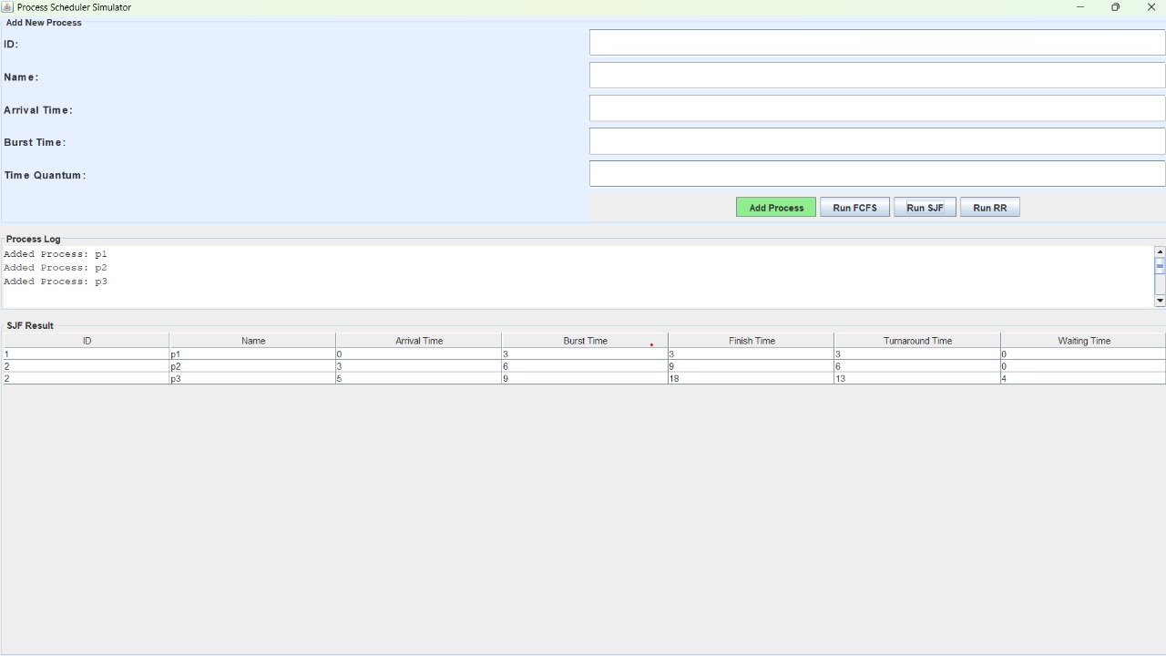

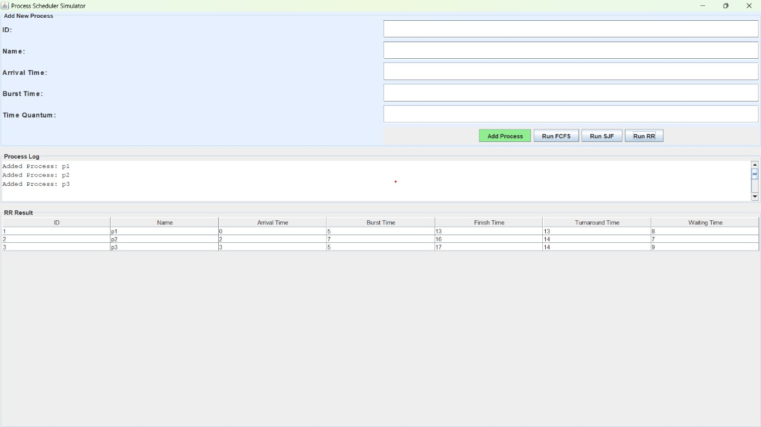

Thank You

